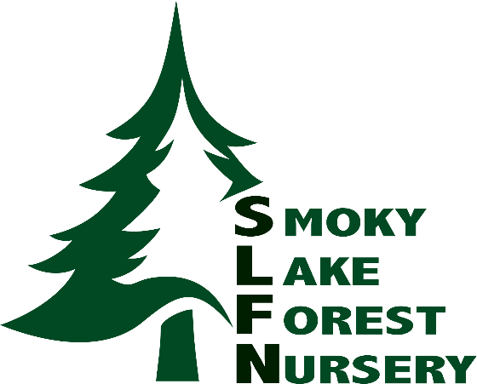
Job Opportunity

Position: Contract General Greenhouse Laborer

Smoky Lake Forest Nursery Ltd. is hiring general greenhouse workers to join our team starting February 5th, 2024, for approximately 5weeks. Job location is approximately 19 km east of Smoky Lake, Alberta.

Key Responsibilities
- Thinning and weeding of seedlings grown in blocks
- Ability to meet daily block quota set out by the operations manager
- Additional duties as required
- Potential to assist with seedling harvest (approx. October to November)

Requirements:
- No experience is necessary!
- Fast-paced environment
- Repetitive tasks
- Handling heavy loads (physically demanding)
- Standing for extended periods
- Bending, crouching, kneeling
- Attention to detail
- Hand-eye co-ordination
- Requires own transportation to/from site

Starting wages at $16/hr. Based on 37.5 hr/week, Monday to Friday (8-4:30). May require shift work and/or extended hours including weekends. Please forward your resume to slfn@c2ctrees.com.

