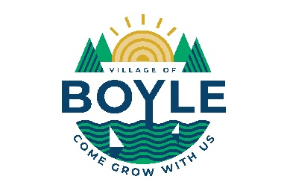
Temporary Summer Employment
The Village of Boyle is accepting applications for temporary summer employment positions. These positions are to start the week of May 27, 2024, or a later date agreed upon to August 23, 2024. The scope of the work will include but not be limited to:
- Mowing grass, weed trimming, garbage pickup and removal
- Cleaning, painting, sweeping, meter reading
- GIS mapping and entry
Job Requirements:
The incumbent candidates must:
- Possess a valid Alberta’s Driver License
- Adhere to all safety policies
- Have the ability to do lifting, bending, walking
- Be able to work in inclement weather, dusty conditions, around unpleasant odors
- Take direction from your supervisor
- Be flexible and open to multi-tasking
- Be able to work independently with little supervision
- Maintain a detailed work completion attitude
For more information call Warren Griffin at 780-689-3643
Or email to warren@boylealberta.com
Or Mail Village of Boyle, Box 9 Boyle, Alberta T0A 0M0
Subject: Summer Employment Position
Only those selected for an interview will be contacted.
Resumes will be accepted until March 22, 2024.

